SUPPLEMENTARY FIGURES, TABLES, NOTES, AND REFERENCES
1. SUPPLEMENTARY FIGURES
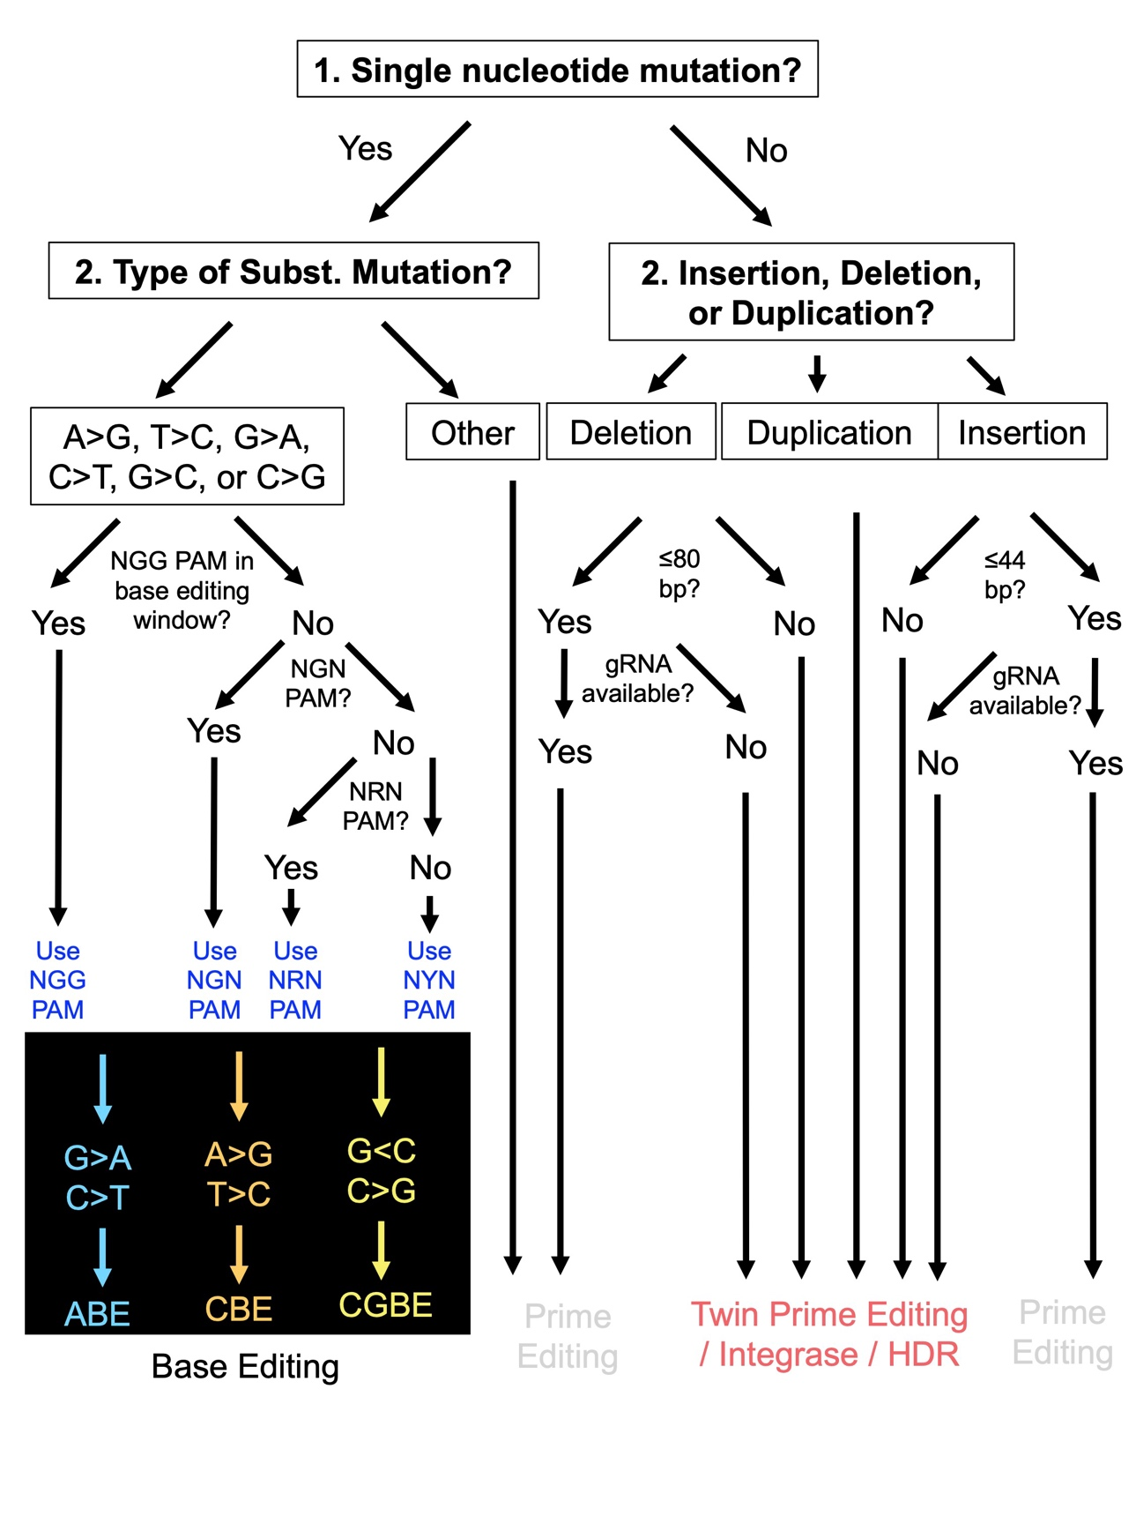
Supplementary Figure 1. Schematic diagram of editABLE algorithm. Mutations are classified as amenable to base editing, prime editing (grey), or other (red). For example, A>G stands for an A>G substitution mutation, which requires a G>A correction via a CBE. For the ADPKD mutation analysis, available PAM sites for ABE and CBE base editors were defined as the presence of NGN nucleotide sequence that positioned the substitution mutation 12-17 bp upstream of the PAM in the 5’ direction, which was identified previously as the most efficient base editing window (1),(2). Available PAM sites for transversion base editors (CGBE) were defined as when, starting from the 5’ direction, the C nucleotide to be edited is in position 6 and an NGG, NGA, or NGN PAM is in positions 21-23 (3). BP = base pair, PAM = protospacer-adjacent motif, gRNA = guide RNA, ABE = adenine base editor, CBE = cytosine base editor, CGBE = transversion base editor, HDR = homology directed repair.

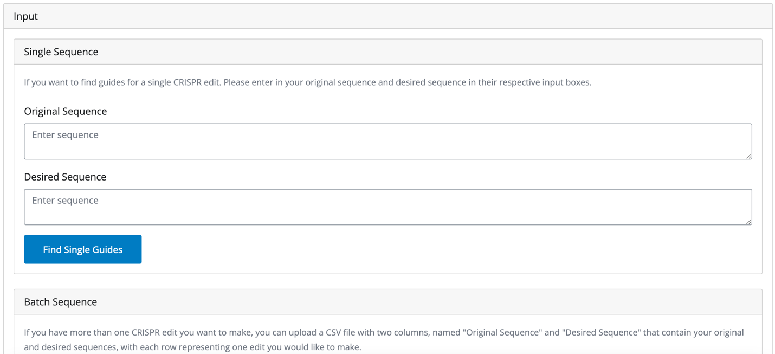
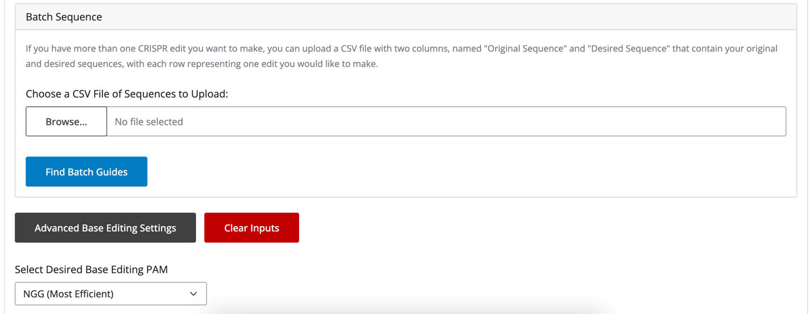
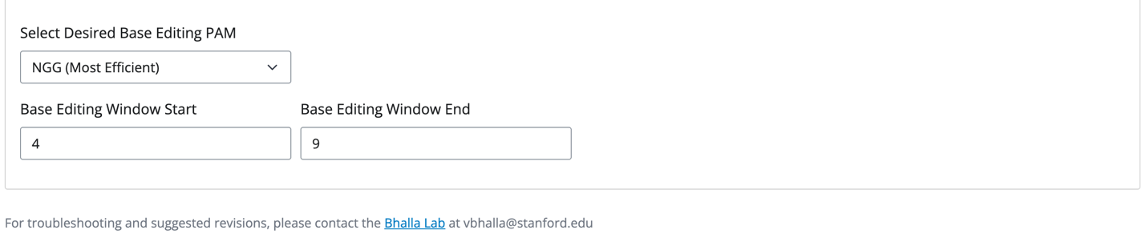
Supplementary Figure 2. Screenshots of the editABLE web application. EditABLE accepts both single sequence data inputted directly into the web application or batch sequence data uploaded as a CSV. Batch sequences should be uploaded into two columns: original sequence and desired sequence. EditABLE also allows advanced users to modify specific base editing settings such as the editing window and PAM. The default PAM setting is NGG and the default base editing window is bases 4 to 9. The base editing window start and end sites are inclusive. Web page accessed July 20, 2024.

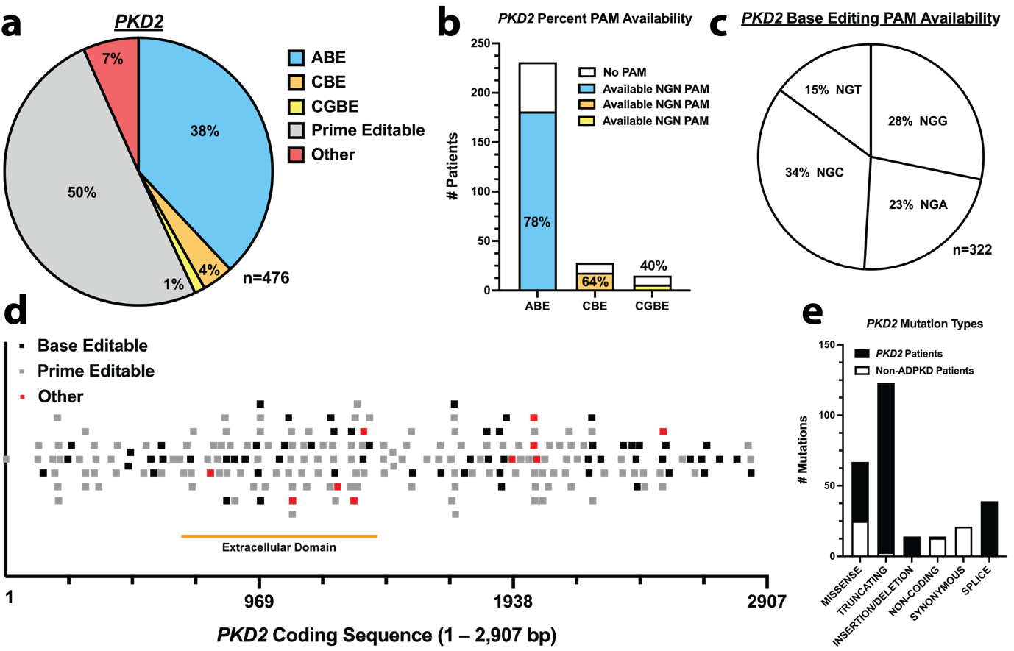Supplementary Figure 3. 93% of PKD2 patients carry mutations correctable via base or prime editing. All PKD2 variants from patients without ADPKD in the Mayo Clinic database were excluded from the analysis. (a) Pie chart showing percentage of patients with PKD2 amenable to each base or prime editing technology. Patients were classified as amenable to base editing (ABE, CBE, or CGBE) if their mutation possessed an NGN PAM sequence that positioned the substitution mutation 12-17 bp upstream of the PAM in the 5’ direction. (b) Bar graph showing percent of patients who possess the appropriate substitution mutations for base editing but do not have NGN PAM sequences available in the optimal editing window. (c) Pie chart showing which third nucleotides are most common in NGN PAM sequences. The data from part (a) are graphed as dotplots against the (d) PKD2 coding region. Each dot represents an individual mutation from the Mayo Clinic ADPKD Mutation Database. All mutations from the Mayo database are shown except large deletion or duplication mutations spanning multiple exons. (e) Bar graph showing a breakdown of mutation types in the ADPKD mutation database with the percent of pathogenic mutations vs. non-ADPKD mutations for each mutation type. ABE, adenine base editor; CBE, cytosine base editor; CGBE, transversion base editor; PAM, protospacer-adjacent-motif.

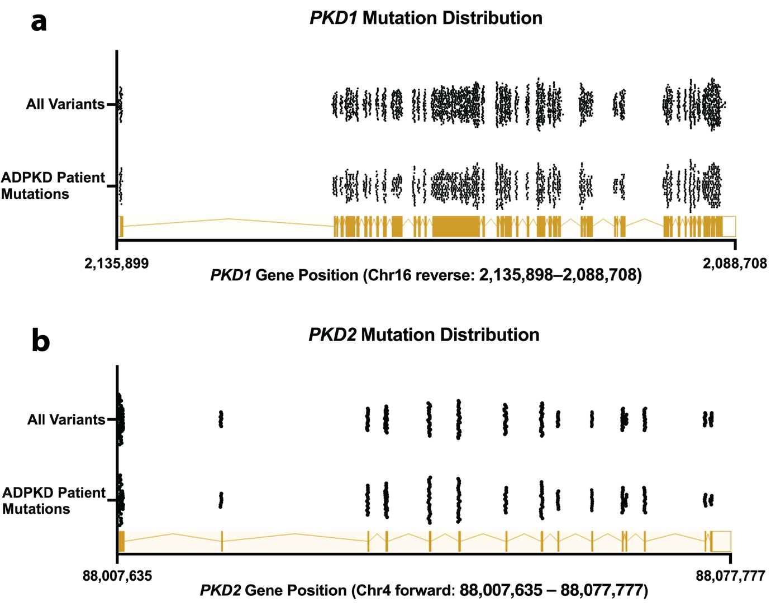Supplementary Figure 4. PKD1 (a) and PKD2 (b) mutations are scattered throughout the genomic region and there are no clear hotspot mutation regions. The full PKD1 (Chr16: 2,135,898 – 2,088,708) and PKD2 (Chr4: 88,007,635 – 88,077,777) genomic sequences are graphed in sense orientation, superimposed with all mutations from the Mayo Clinic ADPKD Database. Mutations from confirmed ADPKD patients are shown in a separate dot plot below all mutation data for PKD1 and PKD2.

2. SUPPLEMENTARY TABLES
EditABLE Feature | Availability in Other Tools | Primary References
Customize base editing window | PnB Designer | (4)
Customize PAM selection | PnB Designer, Benchling | (4)  (5)
Predict off-target and on-target editing efficiency. | Benchling | (5)
Visualize prime editing guide RNAs | PrimeDesign | (6)
Visualize base editing guide RNAs (editing window, PAM, bystander edits) | None
Identify and visualize base editing bystander edits | None
Links to Addgene pages for plasmids for recommended editors and guide RNAs | None
Step-by-step cloning protocol to experimentally validate guide RNAs for base and prime editing. | None

Supplementary Table 1. Full list of editABLE features compared to existing guide RNA design tools. Although several web-based tools exist for each feature, only the primary references are shown. Primary references indicate the existing tools with features most similar to editABLE.

Supplementary Table 2 (XLS FILE). PKD1 mutations for clinical base editing proof-of-concept. Mutations were identified as candidates if they resulted in truncation of PKD1 protein, had been identified in at least 5 unique pedigrees, and were amenable to correction via base editing with an NGN PAM site. The mutations are listed in order of appearance in the PKD1 coding region starting with exon 1. PKD1^{Q2556X} mutation used for in vitro validation in Figure 2 is in bold. EX = exon; Refs. = number of independent sources that cite the mutation.

Supplementary Table 3 (XLS FILE). List of candidate PKD1 mutations amenable to prime editing. Mutations were identified as candidates if they resulted in truncation of PKD1 protein, found in at least 5 unique pedigrees, and amenable to correction via prime editing with an NGG PAM site. Guide RNA sequences were excluded for simplicity since prime editing gRNA design is highly complex; however, the guides can be easily obtained through the editABLE website. The “Edit Type” column is used to indicate the type of prime edit needed to correct the mutation. The mutations are listed in order of appearance in PKD1 starting with exon 1. EX = exon; Refs. = number of independent sources that cite the mutation.

Supplementary Table 4 (XLS FILE). Example batch sequence input file for the editABLE. This batch file contains all the example mutations described in Supplementary Note 2 and highlights the scalability of the editABLE web tool.

Supplementary Table 5 (XLS FILE). Expected results from the editABLE web application for the batch sequence input file in Supplementary Table 3. These results were directly downloaded from editABLE in CSV format.

3. SUPPLEMENTARY NOTES

Supplementary Note 1. Python source code for analyzing the ADPKD mutation database using the editABLE algorithm. Requires installation of pandas, numpy, regex, and Bio packages.

Supplementary Note 2. Example inputs for the editABLE website. Each example includes the reference and edited sequences entered as well as any advanced user settings. If no advanced user settings are shown the default editABLE parameters were used (NGG = PAM, 4 = start base editing window, 9 = end base editing window). The expected output for each example is shown as a screenshot below the inputs.

Supplementary Note 3. Full protocols for long-range and short-range PCR on the PKD1 genomic region containing the candidate PKD1^{Q2556X} mutation.

SUPPLEMENTARY NOTE 1

Python code for the editABLE analysis of the Mayo Clinic ADPKD Mutation Database:

import pandas as pd
import numpy as np
import regex as re
from Bio.Seq import Seq
from Bio.Seq import MutableSeq

"""
This code was written to parse the Mayo Clinic ADPKD Database and count the number of PKD1 and PKD2 Mutations that are amenable to base editing.

IMPORTANT: Before running this script, all deletion mutations (in the cDNA column) must be formatted as firstBase_lastBase with an UNDERSCORE and not a dash. Deletion mutations with a dash will not be counted properly.

"""

# Initializes the reference genome
gene_name = "pkd1"
f = open(gene_name + "_ref_seq.txt", "r")
ref_seq = Seq(f.read()).upper()
f.close()

# Created dictionary with exon start sites in PKD1 or PKD2 genes
genom_exon_ss = pd.read_csv(gene_name + '_genomic_exon_start_sites.csv', header=None, index_col=0).squeeze(1).to_dict()
cds_exon_ss = pd.read_csv(gene_name + '_cds_exon_start_sites.csv', header=None, index_col=0).squeeze(1).to_dict()
exon_sizes = pd.read_csv(gene_name + '_exon_sizes.csv', header=None, index_col=0).squeeze(1).to_dict()
PAMs = re.compile("[A|T|G|C]G")
reverse_PAMs = re.compile("C[A|T|G|C]")
edit_start = 4
edit_end = 9
gRNA_size = 20
pam_length = 2

############ DO NOT CHANGE ANY PARAMETERS BELOW THIS LINE ############

# Helper function to reformat exons and introns as numbers to be used for finding gene positions
def exon_numbering(region, mutation_type):
if "LARGE" in mutation_type:
return "LARGE"
elif ("UTR" in region) and ("5" in region):
return "5UTR"
elif ("UTR" in region) and ("3" in region):
return "3UTR"
elif ("-" in region) or ("_" in region):
return "COMPLEX"
elif "EX" in region:
return int(re.findall(r'\d+', region)[0])
elif "IVS" in region:
return re.findall(r'\d+', region)[0] + "I"
else:
return "ERROR"

# Helper function to add nt position within full gene sequence to initial dataset
def full_gene_position(cDNA, exon):
if "LARGE" in str(exon):
return "LARGE"
elif str(exon).isdigit():
return genom_exon_ss[exon] + (int(re.findall('\d+', cDNA)[0]) - cds_exon_ss[exon])
elif "I" in str(exon):
intron_num = int(re.findall(r'\d+', exon)[0])
if "+" in cDNA:
return genom_exon_ss[intron_num] + exon_sizes[intron_num] + int(re.findall('\d+', cDNA.split('+')[1])[0])
elif "-" in cDNA:
return genom_exon_ss[intron_num + 1] + 1 - int(re.findall('\d+', cDNA.split('-')[1])[0])
elif "_" in cDNA:
return genom_exon_ss[intron_num + 1]
else:
return "FALSE"
elif "5UTR" in exon:
coding_region_start = min(genom_exon_ss, key=genom_exon_ss.get)
return genom_exon_ss[coding_region_start] - int(re.findall('\d+', cDNA.split('-')[1])[0])
elif "3UTR" in exon:
coding_region_end = max(genom_exon_ss, key=genom_exon_ss.get)
return exon_sizes[coding_region_end] + genom_exon_ss[coding_region_end] + int(re.findall('\d+', cDNA.split('*')[1])[0])
elif "COMPLEX" in str(exon):
return "COMPLEX"
else:
return "ERROR"

# Helper function to add coding sequence nt position to initial dataset
def cds_position(cDNA, exon):
if "LARGE" in str(exon):
return "LARGE"
elif str(exon).isdigit():
return int(re.findall('\d+', cDNA)[0])
elif "I" in str(exon):
intron_num = int(re.findall(r'\d+', exon)[0])
if "+" in cDNA:
return cds_exon_ss[intron_num] + exon_sizes[intron_num] + int(re.findall('\d+', cDNA.split('+')[1])[0])
elif "-" in cDNA:
return cds_exon_ss[intron_num + 1] - int(re.findall('\d+', cDNA.split('-')[1])[0])
elif "_" in cDNA:
return cds_exon_ss[intron_num + 1]
else:
return "ERROR"
elif "5UTR" in str(exon):
return
elif "3UTR" in str(exon):
return
elif "COMPLEX" in str(exon):
return "COMPLEX"
else:
return "ERROR"

# Helper function to add mutations definitions to initial dataset
def mutation_types(cDNA):
if ("del" in cDNA) & ("ins" in cDNA):
return "COMPLEX"
elif "dup" in cDNA:
return "FALSE"
elif ("C>T" in cDNA) | ("G>A" in cDNA):
if "," in cDNA:
return "COMPLEX"
else:
return "ABE"
elif ("T>C" in cDNA) | ("A>G" in cDNA):
if "," in cDNA:
return "COMPLEX"
else:
return "CBE"
elif ("C>G" in cDNA) | ("G>C" in cDNA):
if "," in cDNA:
return "COMPLEX"
else:
return "TRANS"
elif "del" in cDNA:
if ("-" in cDNA) | ("+" in cDNA):
return "COMPLEX"
if "_" in cDNA:
start = cDNA.split('_')[0]
end = (cDNA.split('_')[1]).split('del')[0]
if end == "3'UTR":
end = 14138
if (int(end) - int(start)) <= 44:
return "PRIME INSERTION"
else:
return "FALSE"
else:
if len(cDNA.split('del')[1]) <= 44:
return "PRIME INSERTION"
else:
return "ERROR"
elif "ins" in cDNA:
if "_" in cDNA:
num = cDNA.split('ins')[1]
if num.isdigit():
if int(num) <= 80:
return "PRIME DELETION"
else:
return "FALSE"
elif len(num) <= 80:
return "PRIME DELETION"
else:
return "FALSE"
else:
if len(cDNA.split('ins')[1]) <= 80:
return "PRIME DELETION"
else:
return "ERROR"
elif ("T>G" in cDNA) | ("G>T" in cDNA) | ("A>C" in cDNA) | ("C>A" in cDNA) | ("A>T" in cDNA) | ("T>A" in cDNA):
return "PRIME SUBST EDIT"
else:
return "ERROR"

# Helper function to find guide RNAs for ABE and CBE editable mutations on forward/reverse strands
def find_BE_guide_rnas(direction, mutant_seq, genomic_location):
gen_index = genomic_location - 1

if direction == "forward":
start_pams = gen_index + (gRNA_size - edit_end) + 1
end_pams = gen_index + (gRNA_size - edit_start) + pam_length + 1
possible_pams = mutant_seq[start_pams : end_pams]
if len(re.findall(PAMs, str(possible_pams))) == 0:
return "NO PAM"
else:
guideRNAs = []
for match in re.finditer(PAMs, str(possible_pams), overlapped=True):
gRNA = mutant_seq[start_pams + match.start() - gRNA_size: start_pams + match.start()]
guideRNAs.append(str(gRNA))
return guideRNAs

elif direction == "reverse":
start_pams = gen_index - gRNA_size + edit_start - pam_length
end_pams = gen_index - gRNA_size + edit_end
possible_pams = mutant_seq[start_pams : end_pams]
if len(re.findall(reverse_PAMs, str(possible_pams))) == 0:
return "NO PAM"
else:
guideRNAs = []
for match in re.finditer(reverse_PAMs, str(possible_pams), overlapped=True):
gRNA = mutant_seq[start_pams + match.start() + pam_length : start_pams + match.start() + pam_length + gRNA_size]
gRNA.reverse_complement()
guideRNAs.append(str(gRNA))
return guideRNAs
else:
return "ERROR"

# Helper function to find guide RNAs for transversion (C>G and G>C) mutations on forward/reverse strands
def find_trans_guide_rnas(direction, mutant_seq, genomic_location):
gen_index = genomic_location - 1

if direction == "forward":
pam = mutant_seq[gen_index + 15 : gen_index + 15 + pam_length]
if len(re.findall(PAMs, str(pam))) == 0:
return "NO PAM"
else:
return mutant_seq[gen_index + 15 - gRNA_size : gen_index + 15]
elif direction == "reverse":
pam = mutant_seq[gen_index - 15 - 1: gen_index - 15 - 1 + pam_length]
if len(re.findall(reverse_PAMs, str(pam))) == 0:
return "NO PAM"
else:
gRNA = mutant_seq[gen_index - 15 - 1 + pam_length: gen_index - 15 - 1 + pam_length + gRNA_size]
gRNA.reverse_complement()
return gRNA
else:
return "ERROR"

# Adds the base editable guide RNAs to the data table for export
def add_guide_RNAs(cDNA, edit_type, genomic_location):
mutant_seq = MutableSeq(ref_seq)
if "A>G" in cDNA and edit_type == "CBE":
mutant_seq[genomic_location - 1] = "G"
return find_BE_guide_rnas("reverse", mutant_seq, genomic_location)
elif "T>C" in cDNA and edit_type == "CBE":
mutant_seq[genomic_location - 1] = "C"
return find_BE_guide_rnas("forward", mutant_seq, genomic_location)
elif "G>A" in cDNA and edit_type == "ABE":
mutant_seq[genomic_location - 1] = "A"
return find_BE_guide_rnas("forward", mutant_seq, genomic_location)
elif "C>T" in cDNA and edit_type == "ABE":
mutant_seq[genomic_location - 1] = "T"
return find_BE_guide_rnas("reverse", mutant_seq, genomic_location)
elif "G>C" in cDNA and "TRANS" in edit_type:
mutant_seq[genomic_location - 1] = "C"
return find_trans_guide_rnas("forward", mutant_seq, genomic_location)
elif "C>G" in cDNA and "TRANS" in edit_type:
mutant_seq[genomic_location - 1] = "G"
return find_trans_guide_rnas("reverse", mutant_seq, genomic_location)

# Formats raw data from the Mayo Clinic Database, adds mutations definitions, and finds guide RNAs
def format_dataset(df):
df.rename(columns = {'Score' : 'Variant Score'}, inplace=True)
df['# Patients'] = df['#'].apply(lambda x: 0 if '-' in x else x.split('(')[0])
df['# Publications'] = df['#'].apply(lambda y: y.split('-')[1] if '-' in y else y[y.find("(")+1:y.find(")")])
df.drop(columns=['Percent', '#'], inplace=True, axis=1)

# Formats data as integers
df[['# Patients', '# Publications']] = df[['# Patients', '# Publications']].apply(pd.to_numeric, downcast='integer', axis = 1)
df['# Publications'] = df['# Publications'].astype('Int64')
df['# Patients'] = df['# Patients'].astype('Int64')
df['Codon'] = df['Codon'].astype('Int64')

# Adds additional fields to dataset to help with guide RNA finding
df['Edit Type'] = df.apply(lambda x: mutation_types(x['cDNA Change']),axis=1)
df['Exon'] = df.apply(lambda x: exon_numbering(x['Region'], x['Mutation Type']),axis=1)
df['Genomic Location'] = df.apply(lambda y: full_gene_position(y['cDNA Change'], y['Exon']), axis=1)
df['CDS Location'] = df.apply(lambda z: cds_position(z['cDNA Change'], z['Exon']), axis=1)
df['gRNA'] = df.apply(lambda x: add_guide_RNAs(x['cDNA Change'], x['Edit Type'], x['Genomic Location']),axis=1)

return df

# Optional helper function that removes all mutations not found in pedigrees
def remove_null_mutations(df):
df.drop(df.loc[df['# Patients']== 0].index, inplace=True)
return(df)

def main():
# Creates dataset and outputs to CSV
df = remove_null_mutations(format_dataset(pd.read_csv(gene_name + "_germline_mutations.csv")))
#df = df.loc[df["Edit Type"].str.contains("ABE") | df["Edit Type"].str.contains("CBE") | df["Edit Type"].str.contains("TRANS")]
df.to_csv('output.csv')

if __name__ == "__main__":
main()

SUPPLEMENTARY NOTE 2

All examples in this section use default settings for base editing in the editABLE web application (NGG PAM and a base editing window of 4 to 9 within a 20 bp guide RNA).

Example 1 – Human PKD1 Base Editing with NGG PAM site
Sequence change: Correction of PKD1^{Q2556X} substitution, truncating mutation (7). Revert T (mutant) to C (wildtype).

Original Sequence: GTTTCAGGCCACACTTCGAGGTGGGCCTGGCCGTGGTGGTGTAGGACCAGCTGGGAGCCGCTGTGGTCGCCCTCAACAGGTGAGCCAGGCCGTGGGAGGGCGCCC

Desired Sequence: GTTTCAGGCCACACTTCGAGGTGGGCCTGGCCGTGGTGGTGCAGGACCAGCTGGGAGCCGCTGTGGTCGCCCTCAACAGGTGAGCCAGGCCGTGGGAGGGCGCCC

Expected Output:
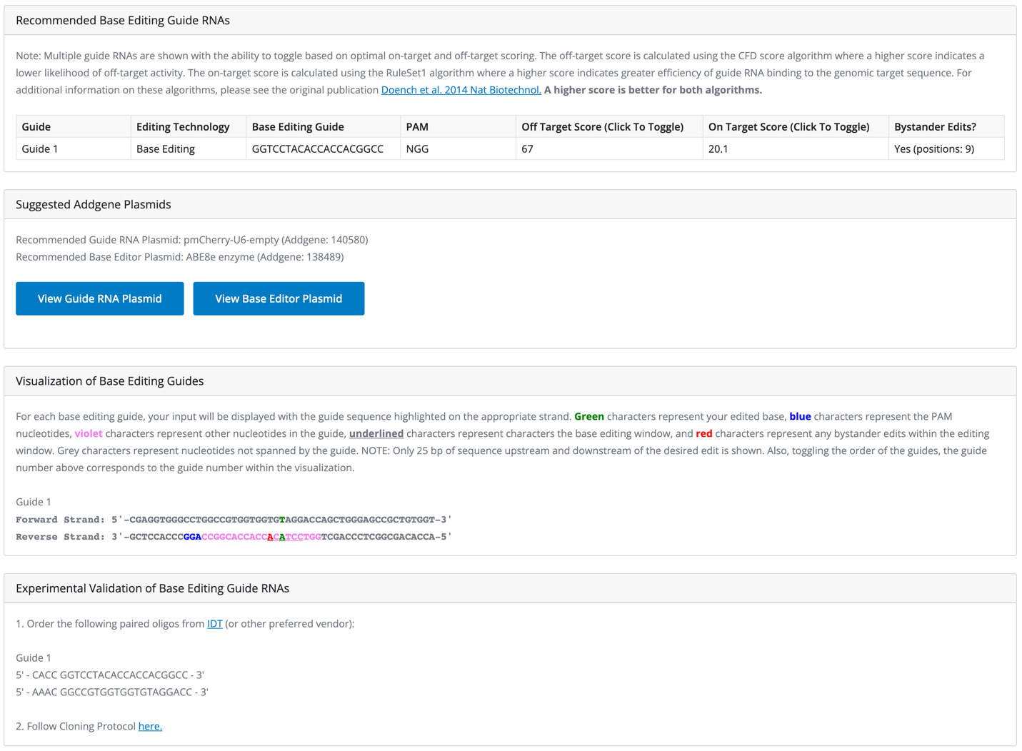
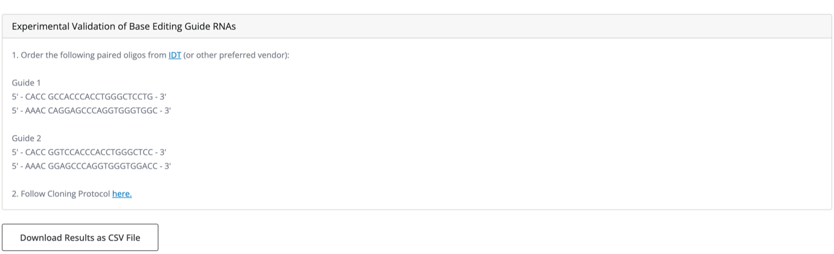

Example 2 – Human PKD1 Base Editing with NYN PAM site
Sequence change: Correction of PKD1^{C155Y} substitution, non-truncating mutation. Revert A (mutant) to G (wildtype) (8).

Original Sequence: ACTGTGGCCTGGCGTGGCTGCCGCGATGGGCGGAGGAGCAGCAGGTGCGGGTGGTGCAGCCCGAGGCAGCCACGTATGCTGGGCCTGGCTCCCTGGCTGGCCAGCCTCTGCTTGGCA

Desired Sequence: ACTGTGGCCTGGCGTGGCTGCCGCGATGGGCGGAGGAGCAGCAGGTGCGGGTGGTGCAGCCCGAGGCAGCCACGTGTGCTGGGCCTGGCTCCCTGGCTGGCCAGCCTCTGCTTGGCA

Expected Output:
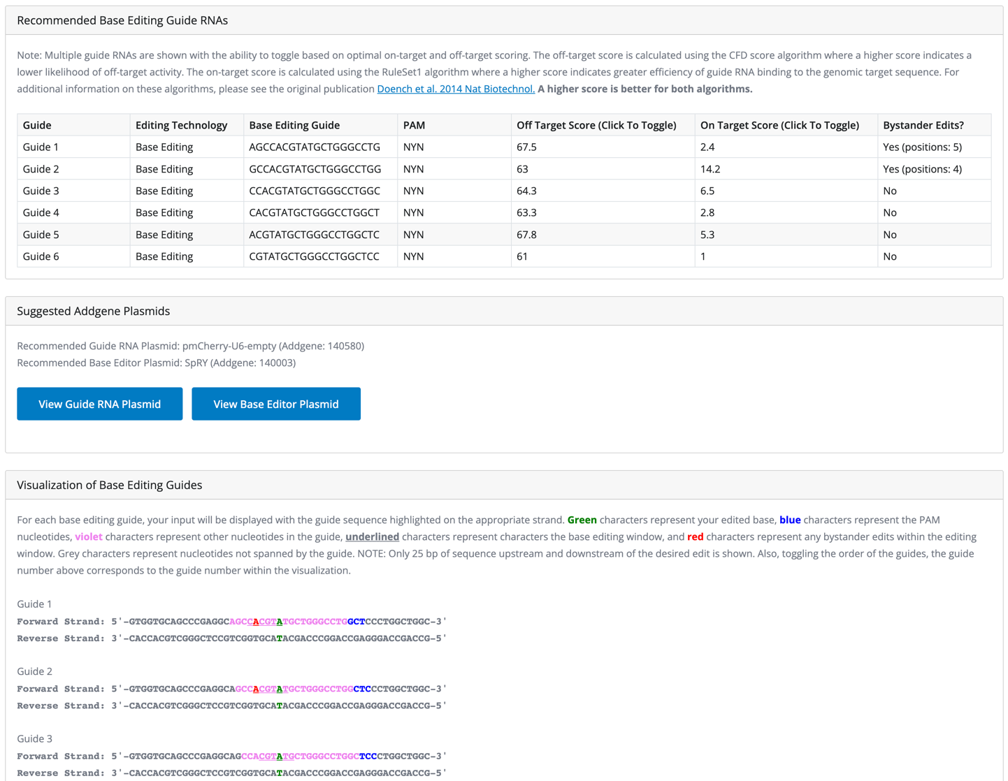
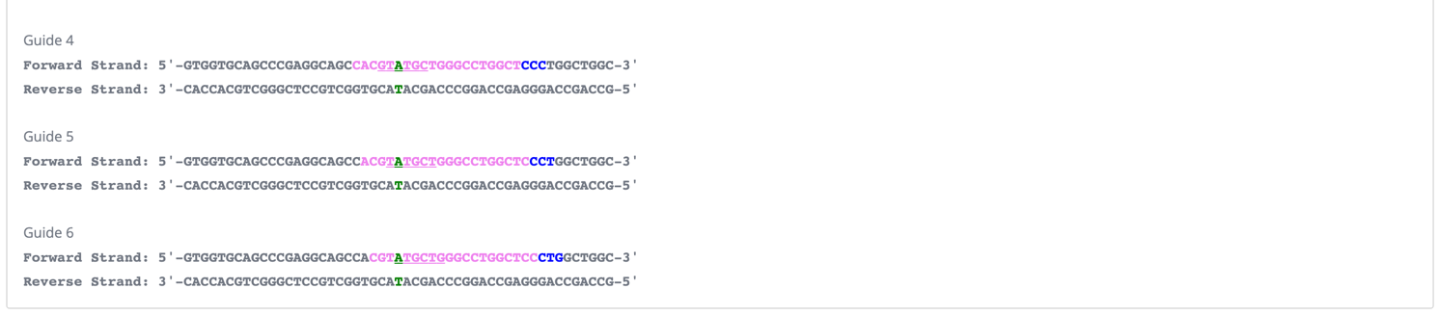

Example 3 – Human PKD1 Prime Editing
Sequence change: Correction of PKD1^{R1672fs97X} frameshift, truncating mutation. Insert AG to correct two deleted bases (9).

Original Sequence: ACCAACGTCTCCTACAGCTGGACTGCCTGGAGGGAC--GGGCCCGGCCCTGGCCGGCAGCGGCAAAGGCTTCTCGCTC

Desired Sequence:
ACCAACGTCTCCTACAGCTGGACTGCCTGGAGGGACAGGGGCCCGGCCCTGGCCGGCAGCGGCAAAGGCTTCTCGCTC

Expected Output:
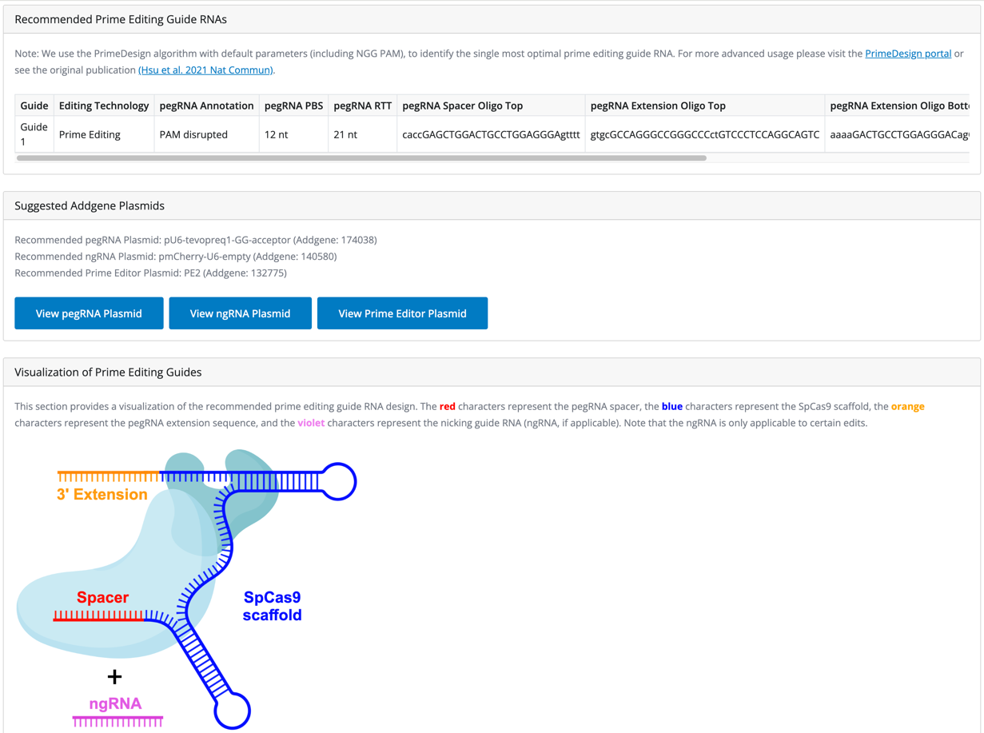
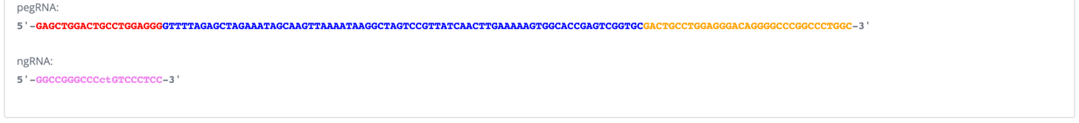
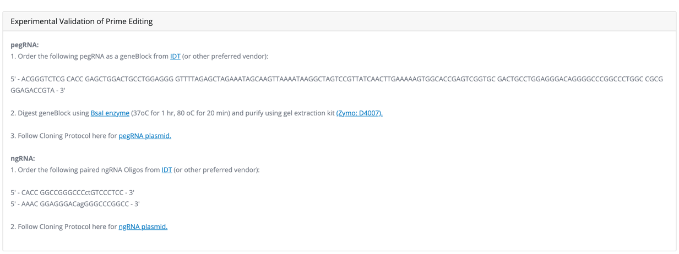
Example 4 – Mouse PKD1 Base Editing
Sequence change: Correction of Pkd1^{T3041A} substitution, non-truncating mutation. Revert G (mutant) to A (wildtype) (10),(11).

Original Sequence: ATGATGATGTGGAGAACTGAGGGCATTGTACCCCTGGAGGAGACCTCACCCAGCCAGGCTGTCTGCCTCACCCGCCACCTCGCTGCCTTCGGTGCCAGCCTTTTTGTGCCTCCCAGC

Desired Sequence: ATGATGATGTGGAGAACTGAGGGCATTGTACCCCTGGAGGAGACCTCACCCAGCCAGGCTGTCTGCCTCACCCGCCACCTCACTGCCTTCGGTGCCAGCCTTTTTGTGCCTCCCAGC

Expected Output:
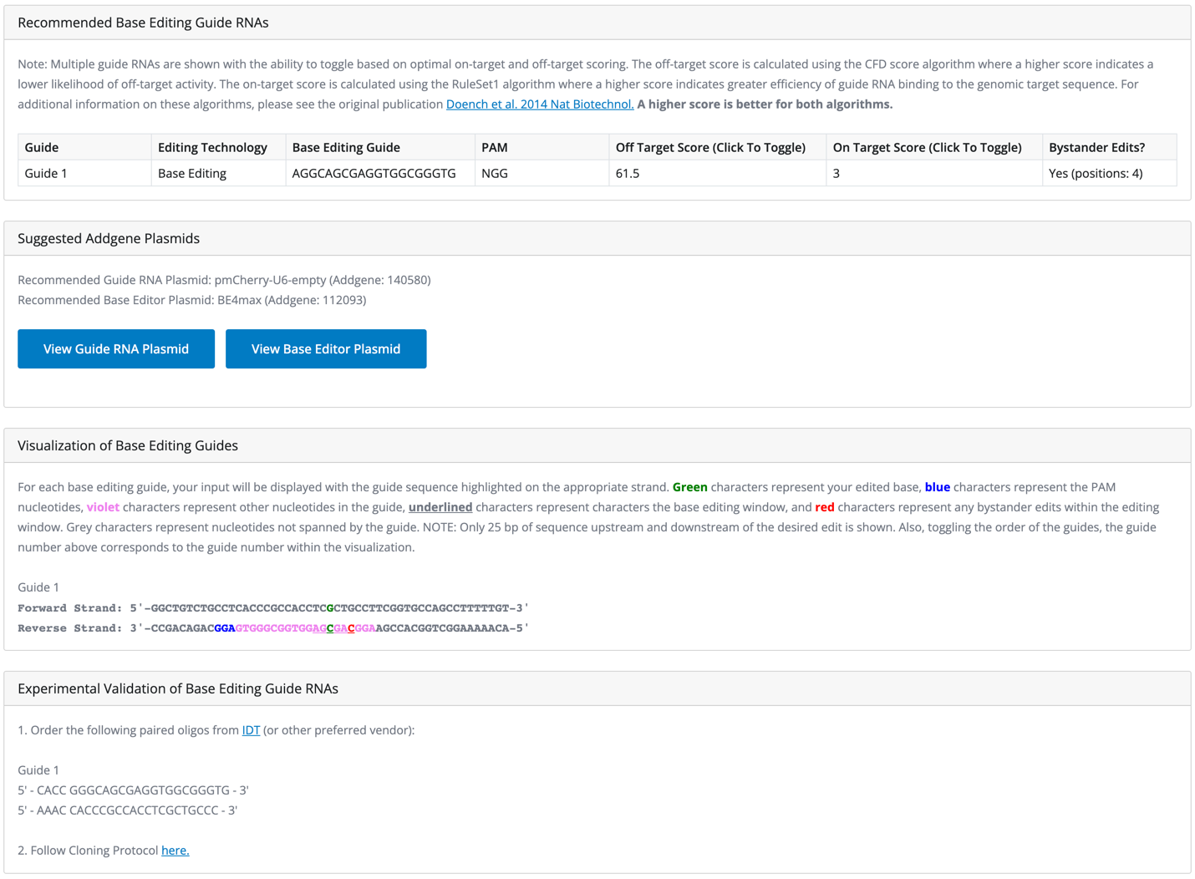


Example 5 – Mouse PKD1 Base Editing with SaCas9 PAM (NNGRRT)
Sequence change: Correction of Pkd1^{S3170G} substitution, non-truncating mutation. Revert G (mutant) to A (wildtype).

Original Sequence: GAGCCTTTCATCGAAACAGCCTGGACATCTTCCAAATTGCCACCCCGCACAGCCTGGGCGGCGTGTGGAAGATCCGAGTGTGGCATGATAACAAAGGTCTGGGTGATAACTGGTGTC

Desired Sequence: GAGCCTTTCATCGAAACAGCCTGGACATCTTCCAAATTGCCACCCCGCACAGCCTGGGCAGCGTGTGGAAGATCCGAGTGTGGCATGATAACAAAGGTCTGGGTGATAACTGGTGTC

Advanced Setting, Base Editing PAM: NNGRRT (SaCas9)

Expected Output:
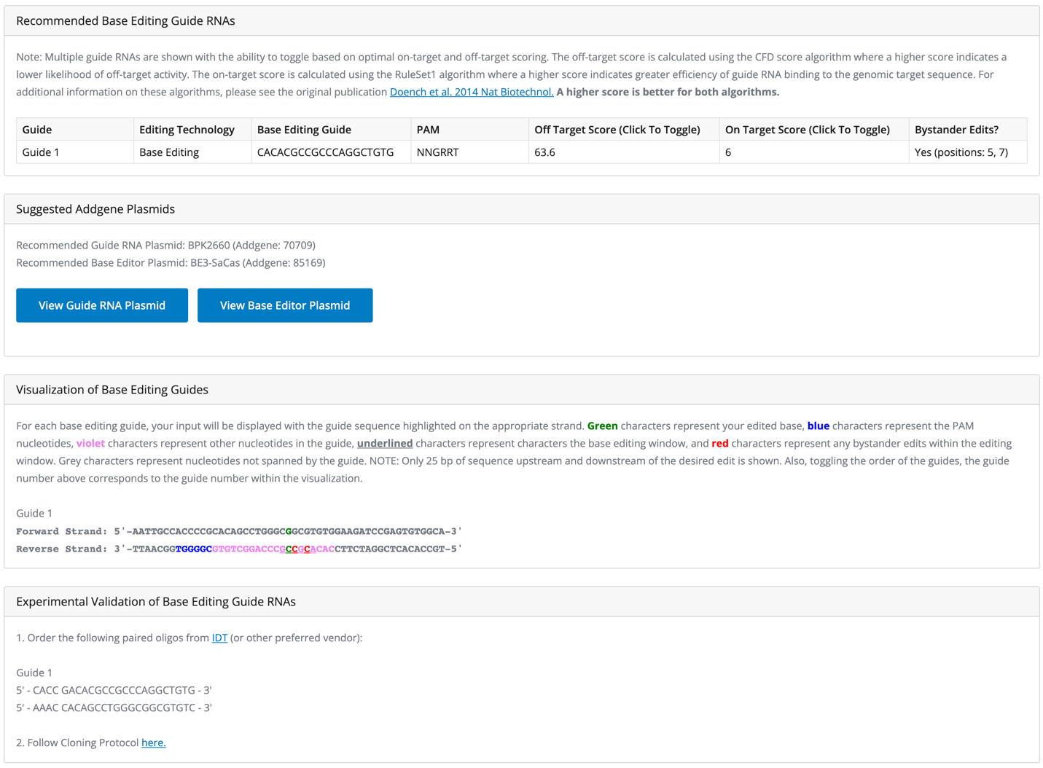


Example 6 – Prime Editing for Human Sickle Cell Mutation (HBB gene)
Sequence change: Correction of HBB p.E6V substitution mutation. Revert T (mutant) to A (wildtype) (12).

Original Sequence: GAGCCATCTATTGCTTACATTTGCTTCTGACACAACTGTGTTCACTAGCAACCTCAAACAGACACCATGGTGCATCTGACTCCTGTGGAGAAGTCTGCCGTTACTGCCCTGTGGGGC

Desired Sequence: GAGCCATCTATTGCTTACATTTGCTTCTGACACAACTGTGTTCACTAGCAACCTCAAACAGACACCATGGTGCATCTGACTCCTGAGGAGAAGTCTGCCGTTACTGCCCTGTGGGGC

Expected Output:
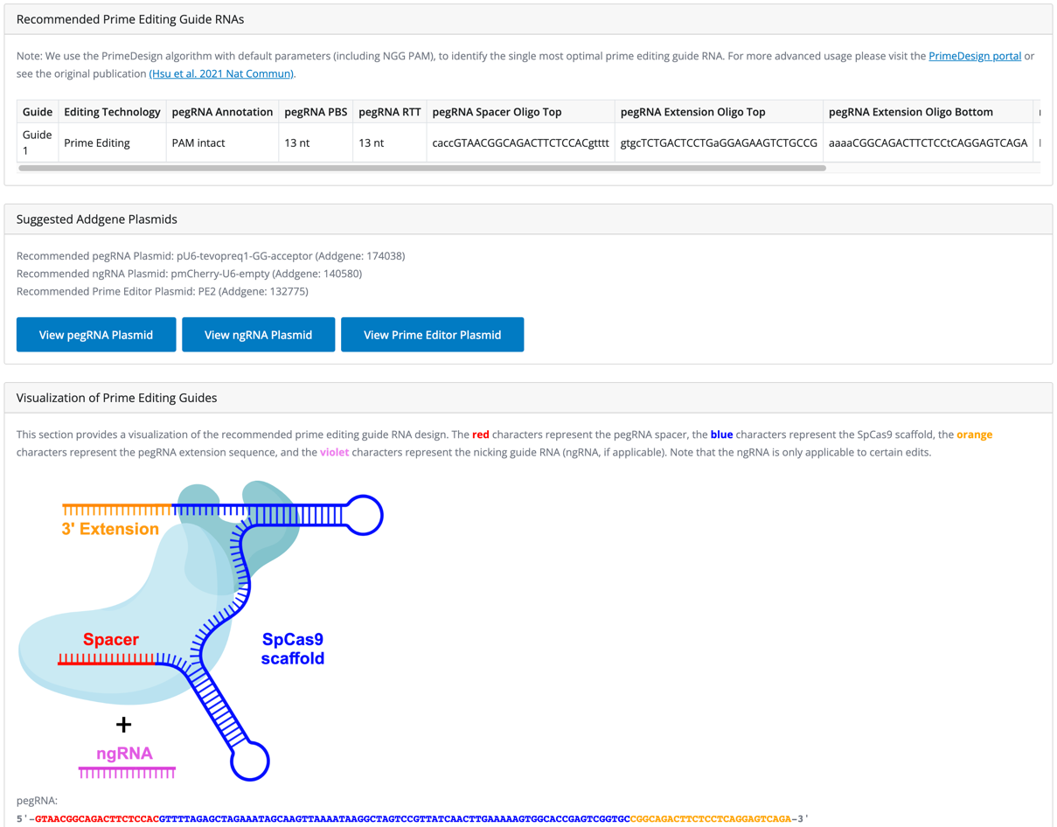
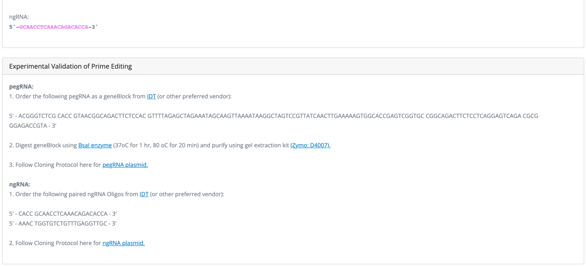
Example 7 – Base Editing for Hutchinson–Gilford progeria syndrome
Sequence change: Correction of human LMNA c.1824 C>T splicing mutation. Revert T (mutant) to C (wildtype) (13).

Original Sequence: ACCTGCGGGCAGCCTGCCGACAAGGCATCTGCCAGCGGCTCAGGAGCCCAGGTGGGTGGACCCATCTCCTCTGGCTCTTCTGCCTCCAGTGTC

Desired Sequence: ACCTGCGGGCAGCCTGCCGACAAGGCATCTGCCAGCGGCTCAGGAGCCCAGGTGGGCGGACCCATCTCCTCTGGCTCTTCTGCCTCCAGTGTC

Expected Output:
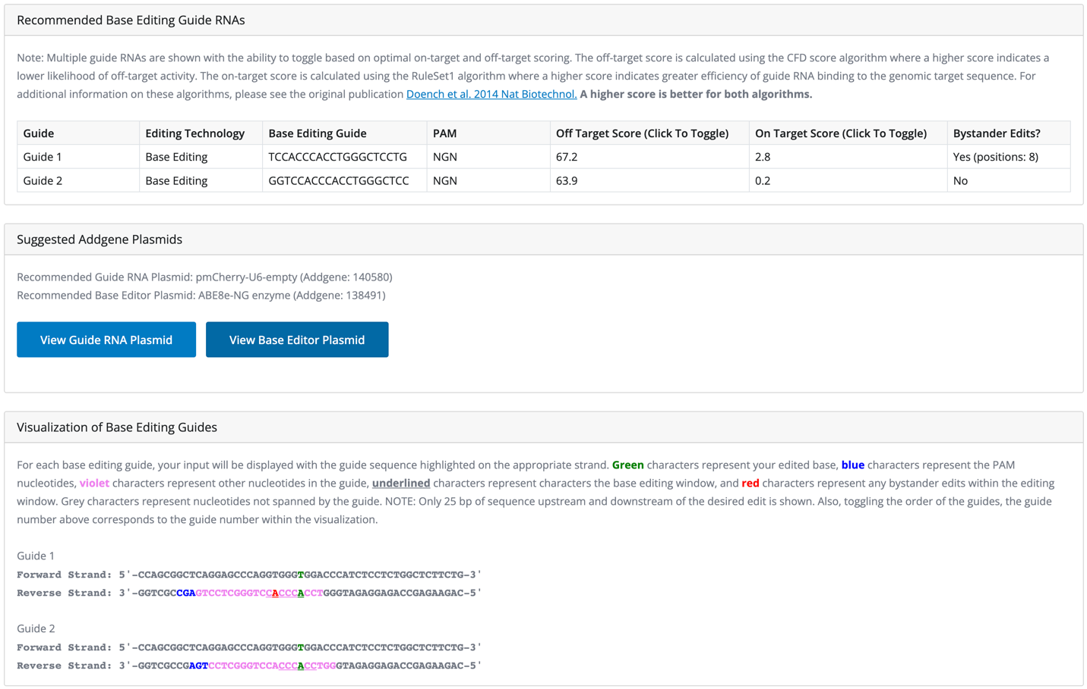
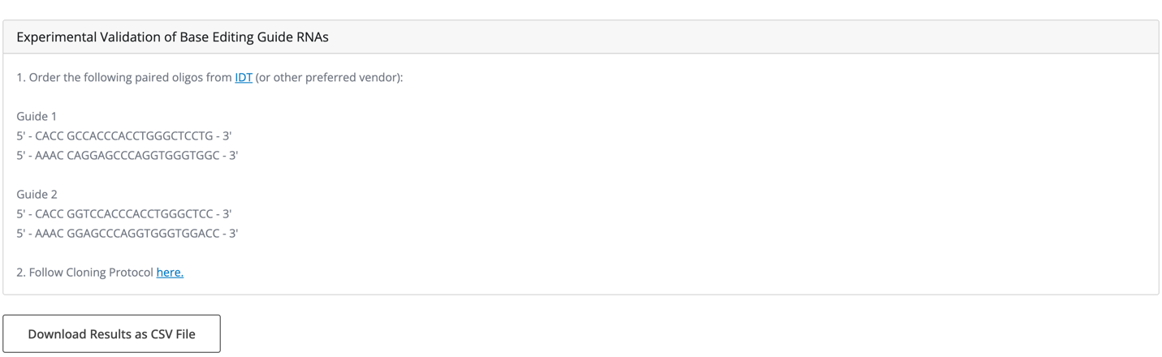

SUPPLEMENTARY NOTE 3

Full Long-Range PKD1 PCR Protocol (Exons 13-21)

The long range protocol is based on protocols previously described with slight modifications (14),(15).

PKD1_Ex13-21_FWD Primer: TGAGTGGAGGGAGGGACGCCAAT
PKD1_Ex13-21_REV Primer: GACAGAACGGCTGAGGCTACTG

Reagent | μL/rxn
PKD1_Ex13-21_FWD primer (20 μM) | 0.13
PKD1_Ex13-21_REV primer (20 μM) | 0.13
10mM dNTP's (New England Biolabs: N0447S) | 2.00
5X NEB LongAmp Buffer (New England Biolabs: M0323S) | 5.00
DMSO (100%) | 1.25
LongAmp Taq (New England Biolabs: M0323S) | 1.00
Nuclease free water | 14.49
TOTAL | 24.00
Add 1 μL DNA template (1 – 250 ng) to make 25 μL final reaction volume.

Thermocycler Conditions:
Temp (°C) | 95 | 95 | 75* | 66 | 95 | 65 | 66 | 66 | 4
Time (min) | 3:00 | 1:00 | 1:00 | 7:30 | 1:00 | 1:00 | 7:00 | 10:00 | infinite
Cycles |  | x10 |  |  | x25
*Gradually decrease by 1°C per cycle.

Short-Range PKD1 PCR Protocol on Exon 19 (PKD1^{Q2556X} mutation)

We dilute the long-range product 1:100 and then use 1 μL of this diluted product as the template DNA in the short-range PCR.

Reagent | μL/rxn
PKD1_Ex19_FWD primer (10 μM) | 0.50
PKD1_Ex19_REV primer (10 μM) | 0.50
2X OneTaq Master mix (New England Biolabs: M0482S) | 12.50
Nuclease free water | 10.50
TOTAL | 24.00
Add 1 μL diluted long-range DNA template (1 – 250 ng) to make 25 μL final reaction volume.

Thermocycler Conditions:
Temp (°C) | 95 | 95 | 49 | 72 | 72 | 4
Time (min) | 2:00 | 0:15 | 0:15 | 0:30 | 5:00 | infinite
Cycles |  | x35

4. SUPPLEMENTARY REFERENCES
1. Gaudelli NM, Komor AC, Rees HA, Packer MS, Badran AH, Bryson DI, et al. Programmable base editing of A•T to G•C in genomic DNA without DNA cleavage. Nature. 2017 23;551(7681):464–71.
2. Komor AC, Kim YB, Packer MS, Zuris JA, Liu DR. Programmable editing of a target base in genomic DNA without double-stranded DNA cleavage. Nature. 2016 May 19;533(7603):420–4.
3. Kurt IC, Zhou R, Iyer S, Garcia SP, Miller BR, Langner LM, et al. CRISPR C-to-G base editors for inducing targeted DNA transversions in human cells. Nat Biotechnol. 2021 Jan;39(1):41–6.
4. Siegner SM, Karasu ME, Schröder MS, Kontarakis Z, Corn JE. PnB Designer: a web application to design prime and base editor guide RNAs for animals and plants. BMC Bioinformatics. 2021 Mar 2;22(1):101.
5. Mohr SE, Hu Y, Ewen-Campen B, Housden BE, Viswanatha R, Perrimon N. CRISPR guide RNA design for research applications. FEBS J. 2016 Sep;283(17):3232–8.
6. Hsu JY, Grünewald J, Szalay R, Shih J, Anzalone AV, Lam KC, et al. PrimeDesign software for rapid and simplified design of prime editing guide RNAs. Nat Commun. 2021 Feb 15;12(1):1034.
7. Loghman-Adham M, Nauli SM, Soto CE, Kariuki B, Zhou J. Immortalized epithelial cells from human autosomal dominant polycystic kidney cysts. Am J Physiol Renal Physiol. 2003 Sep;285(3):F397-412.
8. Liu B, Chen SC, Yang YM, Yan K, Qian YQ, Zhang JY, et al. Identification of novel PKD1 and PKD2 mutations in a Chinese population with autosomal dominant polycystic kidney disease. Sci Rep. 2015 Dec 3;5:17468.
9. Iliuta IA, Kalatharan V, Wang K, Cornec-Le Gall E, Conklin J, Pourafkari M, et al. Polycystic Kidney Disease without an Apparent Family History. J Am Soc Nephrol JASN. 2017 Sep;28(9):2768–76.
10. Wang Z, Ng C, Liu X, Wang Y, Li B, Kashyap P, et al. The ion channel function of polycystin-1 in the polycystin-1/polycystin-2 complex. EMBO Rep. 2019 Nov 5;20(11):e48336.
11. Yu S, Hackmann K, Gao J, Gao J, He X, Piontek K, et al. Essential role of cleavage of Polycystin-1 at G protein-coupled receptor proteolytic site for kidney tubular structure. Proc Natl Acad Sci U S A. 2007 Nov 20;104(47):18688–93.
12. Pattabhi S, Lotti SN, Berger MP, Singh S, Lux CT, Jacoby K, et al. In Vivo Outcome of Homology-Directed Repair at the HBB Gene in HSC Using Alternative Donor Template Delivery Methods. Mol Ther Nucleic Acids. 2019 Sep 6;17:277–88.
13. Koblan LW, Erdos MR, Wilson C, Cabral WA, Levy JM, Xiong ZM, et al. In vivo base editing rescues Hutchinson-Gilford progeria syndrome in mice. Nature. 2021 Jan;589(7843):608–14.
14. Hopp K, Cornec-Le Gall E, Senum SR, Te Paske IBAW, Raj S, Lavu S, et al. Detection and characterization of mosaicism in autosomal dominant polycystic kidney disease. Kidney Int. 2020 Feb;97(2):370–82.
15. Tan YC, Michaeel A, Blumenfeld J, Donahue S, Parker T, Levine D, et al. A novel long-range PCR sequencing method for genetic analysis of the entire PKD1 gene. J Mol Diagn JMD. 2012 Jul;14(4):305–13.

